Johnny A. Rojas & Aiden Sitorus, George Nicacio, Jeremiah Hasibuan, Matthew Miller
A LAB REPORT ON BALMER SERIES AND RYDBERG CONSTANT

Theory
The Balmer Series, formalized in 1885 by Johann Jakob Balmer, is a mathematical model describing the quantized relationship between the spectral emission lines of a hydrogen atom and the principal quantum number of the electron’s initial energy state. This relationship is governed by a proportionality constant $R$, known as the Rydberg constant, and is expressed as:
$$\begin{matrix}\frac{1}{λ}\text{=}R\left(\frac{1}{2^{2}}−\frac{1}{n^{2}}\right)\end{matrix}$$
where:
- $λ$ is the wavelength of the emission line (in meters),
- $R$ is the Rydberg constant ($R≈1.097×{10}^{7}m^{−1}$),
- $n$ is the principal quantum number of the initial state ($n\text{>}2$).
This expression specifically describes electron transitions in which the final state of the hydrogen atom corresponds to $n_{f}\text{=}2$, meaning the electron falls to the second energy level. The emitted photon’s wavelength falls within the visible spectrum, producing the characteristic colored lines of the Balmer Series. Given the Rydberg constant, this formula allows us to predict the wavelengths of the spectral emission lines by rearranging the expression accordingly.
To experimentally validate this relationship, one can measure the wavelengths of the spectral lines from a hydrogen source using a diffraction grating setup. The governing relationship for a diffraction grating is:
$$\begin{matrix}m\text{*}λ\text{=}d\text{*}sin(θ)\end{matrix}$$
where:
- $θ$ is the angle of diffraction relative to the incident beam (in degrees),
- $m$ is the order of interference,
- $d$ is the grating spacing — the distance between two consecutive slits (in meters).
Since $d$ is not directly measured, a mercury light source is first used to calibrate the grating. Mercury produces well-known spectral lines whose wavelengths are established, allowing us to solve for $d$ experimentally. Once $d$ is determined, the same grating is used with the hydrogen source to measure the diffraction angles of its spectral lines, from which the corresponding wavelengths are calculated. Finally, these measured wavelengths are substituted back into the Balmer Series equation to compute an experimental value of the Rydberg constant $R$, which can then be compared to the accepted theoretical value.

Conclusion
In Activity 1, a mercury light source was used to experimentally determine the grating spacing $d$ of the diffraction grating through calibration. Using the NIST reference wavelengths for the red, green/cyan, and violet spectral lines of mercury alongside their measured diffraction positions, individual values of $d$ were calculated for each line and averaged, yielding:
$$\begin{matrix}\overset{´}{N}\text{=}989.26\text{lines/mm}⇒\overset{´}{d}\text{=}1.0109×{10}^{−6}\text{m}\end{matrix}$$
This calibrated grating spacing was then used in Activity 2 to measure the wavelengths of the hydrogen spectral lines. The diffraction angles for the red ($n\text{=}3$), green ($n\text{=}4$), and violet ($n\text{=}5$) transitions were recorded, and the corresponding wavelengths were calculated using $λ\text{=}dsin(θ)\text{/}m$. These experimental wavelengths were substituted into the Balmer Series equation to compute an individual Rydberg constant $R$ for each spectral line, summarized in the table below:
Color | $$n$$ | $λ_{\text{exp}}$ (m) | $R_{\text{measured}}$ (m${}^{−1}$)
Red | 3 | $$6.803×{10}^{−7}$$ | $$1.058×{10}^{7}$$
Green | 4 | $$5.414×{10}^{−7}$$ | $$0.985×{10}^{7}$$
Violet | 5 | $$4.611×{10}^{−7}$$ | $$1.033×{10}^{7}$$
Averaging these values yields an experimental Rydberg constant of:
$$\begin{matrix}R_{\text{exp}}\text{=}1.0255×{10}^{7}{\text{m}}^{−1}\end{matrix}$$
Comparing this to the accepted value of $R\text{=}1.0970×{10}^{7}{\text{m}}^{−1}$, the percent error is:
$$\begin{matrix}\text{\%}\text{Error}\text{=}\frac{\text{|}R_{\text{exp}}−R\text{|}}{R}×100\text{=}6.52\text{\%}\end{matrix}$$
This level of agreement validates the Balmer Series relationship within the bounds of experimental uncertainty. The observed discrepancy is likely attributable to systematic errors in the data collection process, particularly in the visual identification of the spectral line positions on the ruler, which introduces uncertainty in the measured $x$ values and consequently in the computed angles $θ$. Additionally, any slight misalignment of the grating or the light source relative to the optical axis would propagate through both activities and contribute to the final error in $R$.

Question
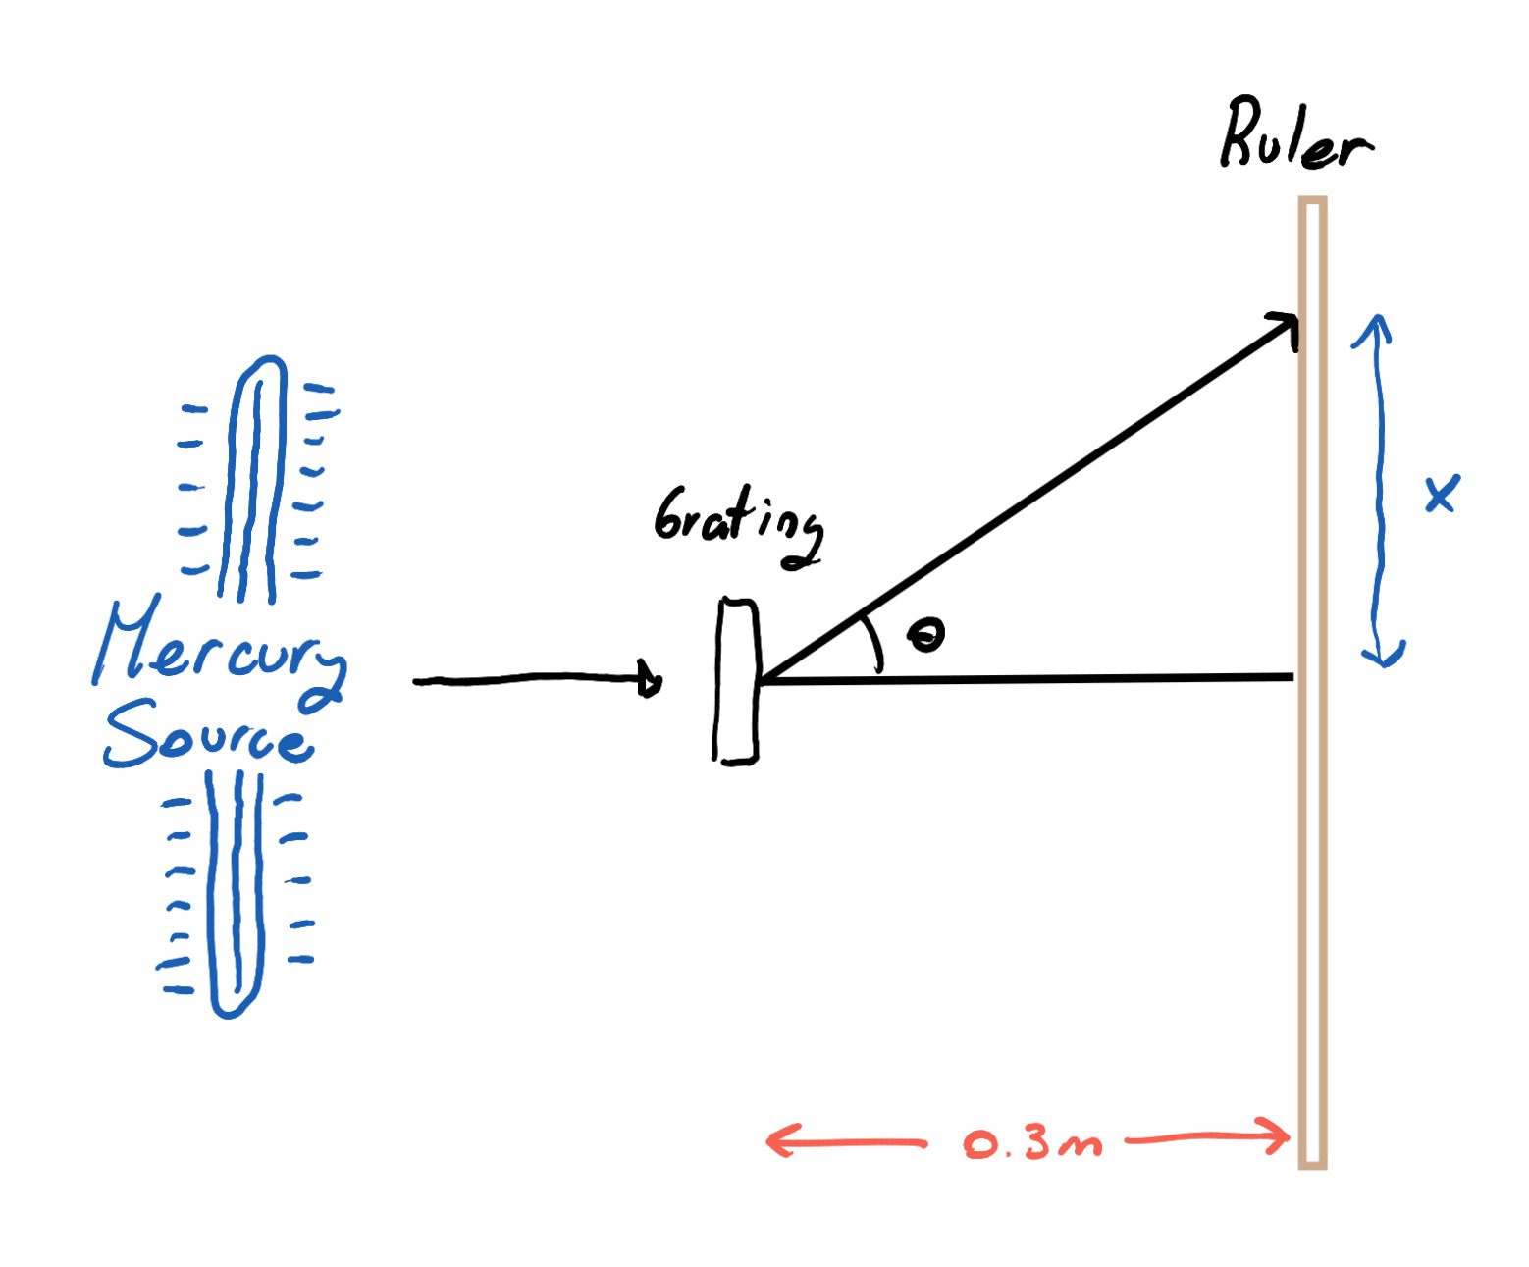
- Set up the mercury light source in front of the diffraction grating and position a ruler perpendicular to the incoming light at a fixed distance of $L\text{=}0.3$ m from the grating.
- For each visible spectral line of mercury (red, green/cyan, and violet), record the positions of the diffracted line on both the right and left sides of the central beam, $x_{right}$ and $x_{left}$, and compute the average displacement:
$$\begin{matrix}x_{avg}\text{=}\frac{x_{right}\text{+}x_{left}}{2}\end{matrix}$$
- Calculate the diffraction angle $θ$ for each spectral line individually using:
$$\begin{matrix}θ\text{=}arctan\left(\frac{x_{avg}}{L}\right)\end{matrix}$$
- Using the known NIST wavelength $λ$ for each mercury line and its corresponding angle $θ$, compute an individual grating spacing $d$ for each line:
$$\begin{matrix}d\text{=}\frac{m⋅λ}{sin(θ)}\end{matrix}$$
- where $m\text{=}1$ is the first order of diffraction.
- Average the three values of $d$ obtained to get a single calibrated grating spacing $\overset{´}{d}$, which is then used in Activity 2:
$$\begin{matrix}\overset{´}{d}\text{=}\frac{d_{red}\text{+}d_{green}\text{+}d_{violet}}{3}⇒\overset{´}{N}\text{=}\frac{1}{\overset{´}{d}}\text{=}989.26\text{lines/mm}\end{matrix}$$

Above and Beyond
The Balmer Series stands as a compelling example of how empirical observation can precede theoretical understanding. When Johann Jakob Balmer derived his formula in 1885, he had no quantum mechanical framework to explain why the spectral lines of hydrogen followed the pattern he described. His work was purely data-driven, a mathematical fit to experimental observations that, at the time, had no deeper justification. Yet the formula worked, and it worked precisely.
It was not until the early twentieth century that Niels Bohr’s atomic model provided the theoretical foundation that Balmer’s empirical formula had been quietly waiting for. Bohr’s quantization of electron energy levels revealed that Balmer’s constant was not arbitrary, it was a direct consequence of the physical structure of the hydrogen atom. Through this theoretical derivation, the Rydberg constant that Balmer had simply fitted to his data could now be expressed entirely from known physical constants, without any experimental input whatsoever.
It is interesting to consider that Balmer had no way of knowing how significant his formula would turn out to be. He simply noticed a pattern in the data and described it as accurately as he could. What followed decades later was not a correction of his work, but a deeper explanation of it, one that showed his measurements had been pointing at something tangible all along.

